Use Cases for ABC Bank Online Banking

Use Case ID | UC 1
Use Case Name | Account Holder online registration
Created By | John Doe |  | Last Updated By | Kathy Green
Date Created | 04/02/2015 |  | Last Revision Date | 04/04/2015
Actors |  | 1. Account holder/User  2. Bank
Description |  | ABC Bank is designing an online banking provision for its account holders. In the current use case we are looking at the first-time user experience where the User is trying to register.
Trigger |  | The users desire to create an online account for online banking
Pre-conditions |  | - The User shall have a valid Account Number  - The User shall think about a User ID and password well in advance to save time
Post-conditions |  | - The user shall have received a confirmation text/email confirming online user account creation.
Assumptions |  | Customer is computer literate and knows how to navigate the internet
Normal Flow |  | - User shall open the ABC online banking website  - User shall select New User registration  - User shall enter Name  - User shall enter Account number  - User shall create New User ID  - User shall create a new Password  - User shall receive a conformation email/text
Alternative Flows |  | - If Step 3 fails  1.1 Enter the name again  - If step 4 fails  2.1 Enter the account number again  - If Step 5 fails  - User ID already exists, type another unique ID  - If Step 6 fails  4.1 User shall enter the PW again and try to follow the rules for creating new password
Exceptions |  | - User facing network issues.  - The Bank Server down which takes down the website  - Any maintenance/outages  - The account number is blocked
Frequency of Use |  | - Once during the account setup/1000 new a ID creations in a day
Special Requirements |  | - Use shall be given an ID/PW creation process manual when opening a new account

Use Case ID | UC2
Use Case Name | Fund Transfer
Created By | John Doe |  | Last Updated By | Kathy Green
Date Created | 04/02/2015 |  | Last Revision Date | 04/04/2015
Actors |  | 1. Account holder/User  2. Bank
Description |  | ABC Bank is designing an online banking provision for its account holders. In the current use case we are looking at the Fund Transfer option for the user.
Trigger |  | The users desire to transfer funds by an online account through online banking
Pre-conditions |  | - The User shall have a valid Account Number.  - The User shall have an online account.  - The User must have sufficient funds to make the transfer.  - The receiver of the funds shall have a valid account number.
Post-conditions |  | - The user shall have received a confirmation text/email confirming online account fund transfer.  - The user shall be provided with the remaining amount.
Assumptions |  | - Customer is computer literate and knows how to navigate the internet.
Normal Flow |  | - User shall open the ABC online banking website  - User shall enter Login and Password using Sign in for existing Users.  - User shall select Fun Transfer Tab from the landing page.  - User shall select the type of fund transfer  - User shall select “From Account”,  - User shall select or add beneficiary.  - User shall enter Amount details in the respective fields.  - User shall select “Transfer”.  - User shall receive a confirmation text/email confirming online account fund transfer.
Alternative Flows |  | - If Step 6 fails  1.1 Verify the beneficiary details and enter again.  - If Step 8 fails,  - User shall check if the amount entered by user is greater than existing amount in the account  - If the amount is more than the specified daily limit, then can enter an amount lesser than that.
Exceptions |  | - User facing network issues.  - User facing server issues.  - User facing database outages.  - User not able to add the desired recipient due to incorrect information
Frequency of Use |  | - Three transfers per day
Special Requirements |  | - The User shall have a recipient added to transfer funds to recipient

Use Case Diagram:

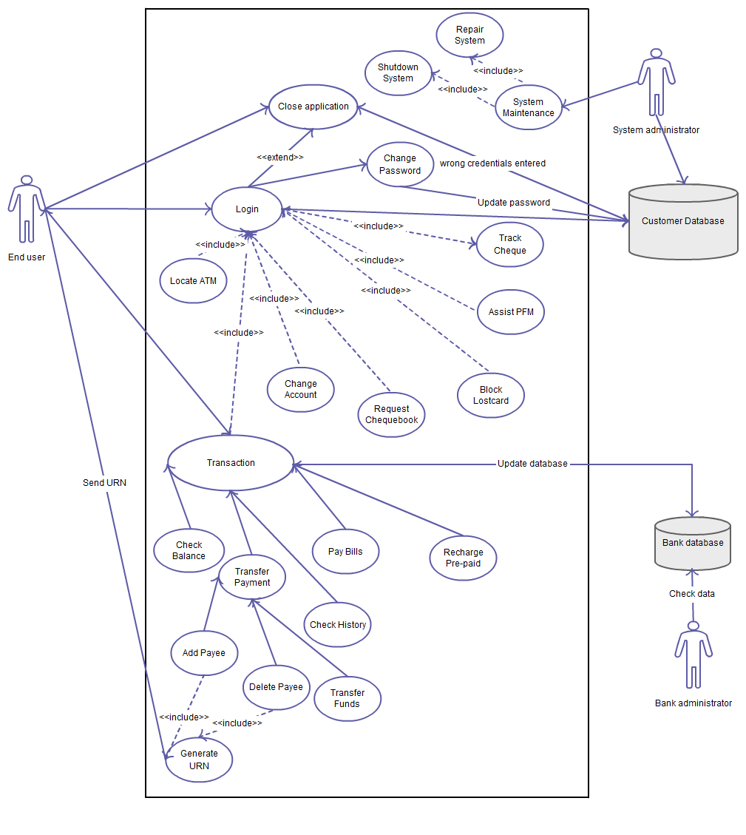

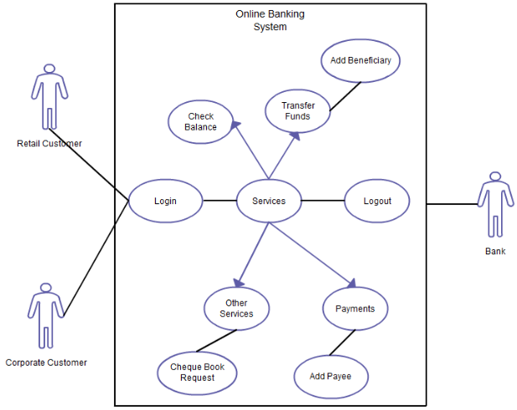

Assignment:

- Create Use Case for

